GOVERNMENT DENTAL COLLEGE AND HOSPITAL , KADAPA.

DEPARTMENT OF PERIODONTOLOGY AND IMPLANTOLOGY.



SEMINAR PRESENTATION ON- “ALVEOLAR BONE”

GUIDED BY: PRESENTED BY:

DR.P.SURESH, DR.K.LATHA,

PROF & HOD. 1ST YEAR PG.

CONTENTS:

* INTRODUCTION
* DEVELOPMENT
* STRUCTURE
* BONE MARROW, PERIOSTEUM , ENDOSTEUM AND INTERDENTAL SEPTUM
* COMPONENTS OF ALVEOLAR BONE
  + CELLS
  + BONE MATRIX
* VASCULAR SUPPLY---- BLOOD SUPPLY

VENOUS DRAINAGE

LYMPHATIC DRAINAGE

* BONE FORMATION
* BONE RESORPTION
* BONE REMODELLING
* ALVEOLAR BONE IN DISEASE
* CONCLUSION
* REFERENCES

INTRODUCTION :

* **Bone :**

Bone is a mineralized connective tissue that performs the function of support, protection and movement.

* **Alveolar process :** 
  + It is the part of the maxilla and mandible that forms and support the sockets of the teeth.
  + It forms when tooth erupts and

disappears gradually after tooth loss.

* Tooth-dependent bony structures.

- Schroeder HE, 1991

**Synonyms :**

* Processus alveolaris
* Pars alveolaris

**DEVELOPMENT:**

* Near the end of the 2nd month of fetal life, mandible and maxilla form a groove that is opened toward the surface of the oral cavity
* As tooth germs start to develop, bony septa form gradually.
* The alveolar process starts developing strictly during tooth eruption.

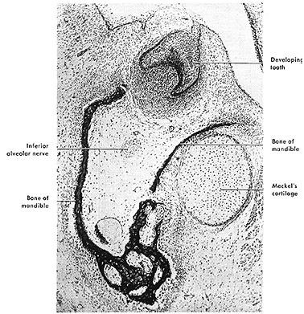

* Osteogenesis :

Process of Bone formation

Endochondral Intra-membranous

Occurs by formation of occurs by lying down a cartilaginous model which of fibrous membrane

is subsequently replaced to that directly clacifies to bone. Bone.

**STRUCTURE :**

* **Alveolar bone**

1. **Alveolar bone proper** 
   * + **Lamellated bone**
     + **Bundel bone**
2. **Supporting alveolar bone** 
   * + **Cortical plate** 
       - **Inner plate**
       - **Outer plate**
     + **Spongy bone** 
       - **Type I**
       - **Type II**

**ALVEOLAR BONE PROPER surrounds the root of teeth and gives attachment to PDL.**

**i. partly lamellated and**

**ii. partly bundle bone**

**i. Lamellated bone :**

* + **forms inner wall of socket**
  + **perforated by many openings (cribriform plate) these openings carry blood vessels.**
  + **interdental and inter radicular septa contain zuckerkand and hirschfeld canals which contain vascular supply.**

**ii.Bundle bone-**

* **Lines the socket where sharpeys fibers are embedded .**
* **Contains more calcium salts per unit area than other types of bone**

**ABP also named as Lamina dura because of its radiopacity.**

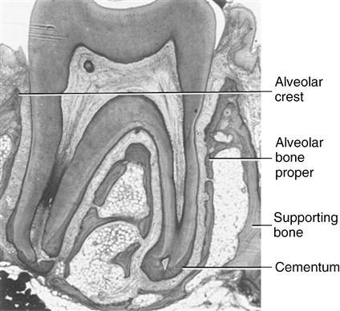

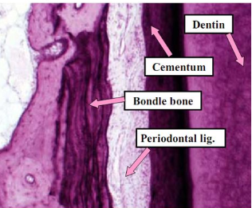

**SUPPORTING ALVEOLAR BONE:**

**Surround alveolar bone proper and supports socket**

**Cortical plate-:**

* consists of compact bone form outer and inner plates of alveolar process, thinner in maxilla than in mandible thicker in premolar and molar region.
* in maxilla outer cortical plate is perforated in mandible it is dense.
* in anterior teeth it is very thin.
* no spongy bone is present and cortical plate is fused with alveolar bone proper.
* cribriform plate and cortical plate are separated by spongy bone.

**Spongy bone**

* Type I- interdental and interradicular trabeculae

regular ladder like arrangement

often seen in mandible

trajectory pattern

* Type II- numerous and irregularly arranged

delicate inter dental and inter radicular trabeculae

lack distinct trabecular pattern

seen in maxilla.

Trabeculae less prominent in upper jaw due to proximity of nasal cavity and sinus

**INTER DENTAL SEPTUM**

* Consist :

Cancellous bone (bordered by socket wall)

Cribriform plate(approximates facial and lingual cortical plate)

Mesiodistal and facio lingual septum dimension depends upon :

* size and convexity of adjacent teeth crown,
* position of teeth in jaw and degree of eruption

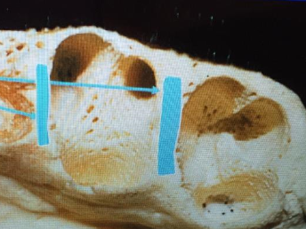

**PERIOSTEUM AND ENDOSTEUM**

* Periosteum- covering outer surface of bone
  + consists :inner layer – osteoblasts surrounded by progenitor cells
  + outer layer- rich in blood vessels and nerves, collagen fibers and fibroblasts
* Endosteum-
* lines internal bone cavities
* single layer of osteoblast and small amount of connective tissue
  + - outer layer – fibrous layer
    - inner layer -osteogenic layer

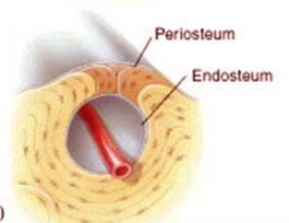

* **Osteon :**
  + It is the structural and microscopic functional unit of bone .
  + It consists of haversian canal in the centre which harbours a blood vessel.
  + It is covered by concentric mineralised circular lamellae.
  + Spaces around these are filled with interstitial lamellae.
* **Haversian system :**

it consists of haversian canal and a volkmanns canal in the centre of osteon

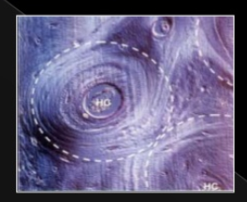

**BONE MARROW**

Common areas in oral cavity are :

* Maxillary tuberosity
* Molar and premolar areas
* Mandibular symphisis
* Ramus angle

Radiographically, these areas appear as zones of RADIOLUCENCY

**MICROSCOPIC STRUCTURE BONE**

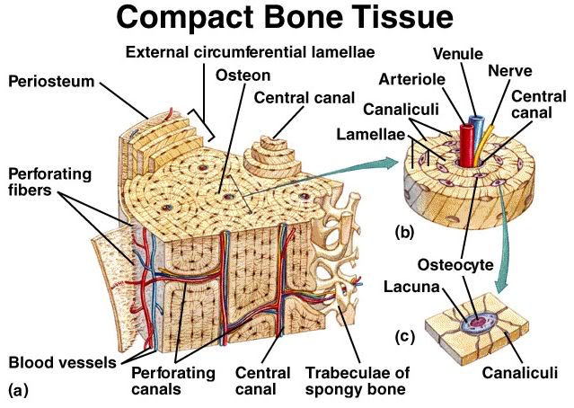

**Woven bone :**

* + it is first formed bone during embryonic development also called as primary bone.
  + it has no concentric lamellae.
  + collagen fibers are arranged irregularly arranged along matrix.
  + **COMPOSITION :**

BONE

**ORGANIC**  **INORGANIC CELLS**

(33%) ( 67 %) osteoblasts

HAP crystals osteoclasts

Collagen non-collagen calcium osteocytes

TYPE 1 OSTEOPONTIN phosphate

TYPE 3 OSTEONECTIN carbonate

TYPE 5 OSTEOCALCIN hydroxyl

TYPE 12 BONE sodium

SIALOPROTEIN magnesium

PROTEOGLYCANS fluorine

BONE MORPHOGENIC

PROTEINS

ORGANIC SUBSTANCES:

**COLLAGEN:**

Sharpeys fibers

* Alveolar bone: Type I, III, V & XII collagen is found.
* Major component (80–90%)
  + Type I collagen(95%)
  + Type V (5%) collagen
* Type I collagen forms heterotypic fiber bundles that provide the basic structural integrity of connective tissue.
* The elastisity of collagen helps to resist fracture.
* The type III collagen with type I collagen present in Sharpey’s fibers.
* Type XII collagen is expressed under mechanical strain.
* Type III and type XII collagen fibers produced by fibroblast.
* The collagen fibrils in bone are stabilized by intermolecular cross-linking for high tensile strength.

**Osteocalcin(15%)**

* also known as bone gla protein
* first noncollagenous bone protein
* Modified by vitamin K–dependent carboxylating enzymes
* bind calcium ions strongly to involve in bone calcification
* treatment with the vitamin K antagonist warfarin reduces osteocalcin levels in bone
* Regulated by vitamin D3 and parathyroid hormone
* Chromosome 1
* Regulates crystal growth in osteiod matrix.

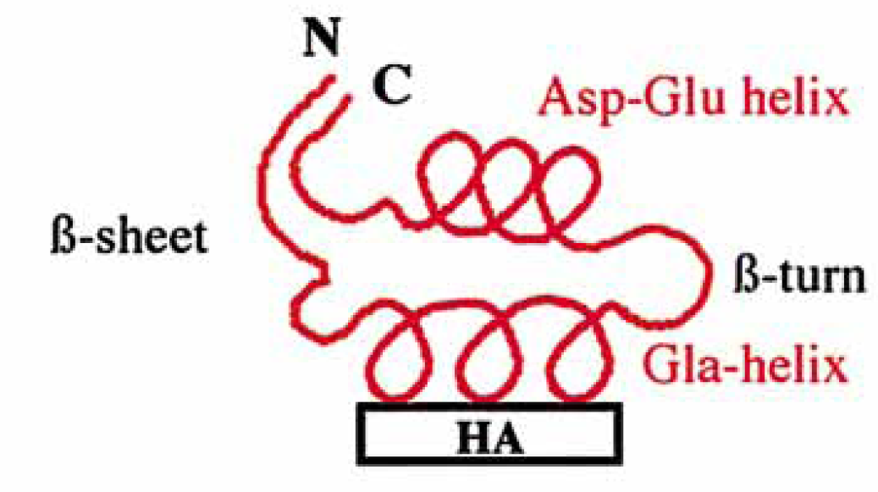

OSTEONECTIN (SPARC)

* Bound to hydroxyapatite
* 25% of the non-collagen proteins
* Has both a high-affinity calcium-binding site and a number of low-affinity calcium-binding sites
* Chromosome 5
* Secreted by osteoblasts, during bone formation.
* Have role in initiation of mineralization,

promotes crystal growth

regulation of cell adesion, proliferation, modulation of cytokine activity.

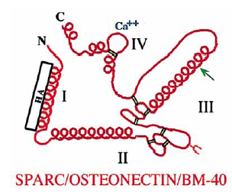

**Osteopontin and bone sialoprotein** :

* characterized as bone sialoproteins I and II.
* Despite the structural similarities , these proteins have different functional roles.

**BSP :** essentially restricted to mineralizing tissues

plays an imp role in initial nucleation for process of mineralization

**OSTEOPONTIN** : plays an imp role in turn over of bone

* The expression of both proteins is stimulated by factors that stimulate bone formation.

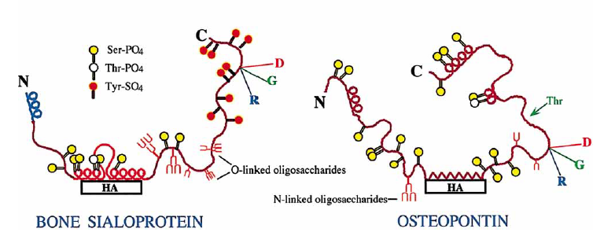

* **Bone proteoglycans**
* Expressed with chondroitin sulfate, dermatan sulfate.
* Chondroitin sulfate seen in osteoblasts.
* biglycan is prominent in developing bone
* decorin is distrubuted among tissues.
* Derman sulfate seen in collagenous matrix
* **Bone Morphogenic protein :**
* progenitor cells of bone .
* Can induce phenotype of

other bone cells

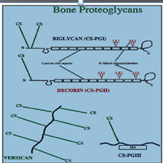

* **Osteoblasts :**

Bone forming cells.

**Origin :**

* Plueripotent stem cells.

* They are mononucleated cells that synthesize

collagenous and non-collagenous

bone matrix proteins.

* They exhibits a high level of ALP

and abundant protein synthetic organelles.

**Morphology:**

* When active---- Cuboidal or slightly elongated cells.
* When non-active---- flatten and extend along surface of bone.
* Osteoblasts that have completed their function lie on the surface **as bone lining cells.**
* **They are removed by apoptosis**

**Osteocytes :**

* As the osteoblasts secrete bone matrix, some of these osteoblasts gets entrapped within the matrix are called osteocytes.

**Morphology :**

* Reduces in size within bony matrix, creating space around it called lacuna.
* Lacuna appears ovoid or flattend.

**Canaliculi :**

* Narrow extensions of lacuna form channels

called canaliculi.

* Permit diffusion of gases, nutrients and

waste products between osteocytes and

blood vessels.

**Function :**

* Sense changes in environment and

send signals that effect response of other

cells involved in bone modelling

* **Osteoclasts :**
* Bone resorbing cells.
* Multi nucleated , large cells found in clusters.

Origin : hematogenic progenitor cells

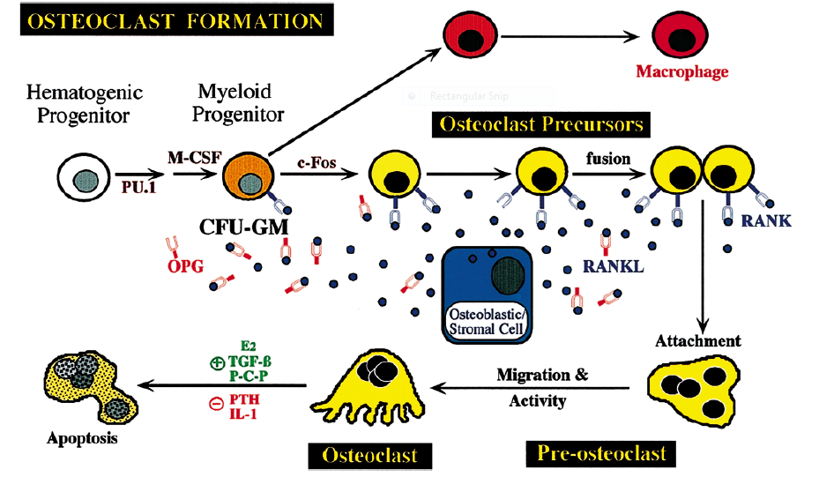

* Striking feature of the osteoclast is the presence of a clear (sealing) zone in the peripheral cytoplasm.
* It delineates a more central region of membrane infoldings (plates) and finger-like processes termed the ruffled border.
* Resorption of bone occurs in an acidified extracellular matrix compartment by combined actions of a variety of ruffled border membrane-associated enzymes.

**Physiological Remodeling (bone turn over ):**

* The process by which overall size and shape of bone is established is referred to as Bone remodelling.
* Starts when the primary dentition is replaced by succedaneous teeth.
* AB is the least stable structure of pdl tissues as it is in constant state of flux.
* Factors influencing are :

Local Systemic

Functional requirements of teeth Parathyroid hormone

Age related changes in bone cells Vitamin D3

Calcitonin

* Occurs by Osteoblast - Osteoclast coupling
* Interdependent each other
* Development of osteoclasts controlled by stromal cells through RANKL/RANK/OPG axis.
* Osteoblasts production by osteoclast action on mineralised matrix of bone.

**It facilitates :**

1.Positional adaptation of teeth in response to functional forces

2. The physiological drift of teeth.

3. Movement of teeth within the jaw bone

* Adaptive remodelling :

seen when there is continous excess forces are present .

ex : TFO

* + bone loss occurs along the long axis of tooth, causing angular defects
  + Bone formation sometimes occurs in an attempt to buttress bony trabeculae weakened by resorption.
  + When it occurs centrally-----central buttressing bone formation
  + peripherally-----peripheral buttressing bone formation
  + Causes bulging of bony contour named as Lipping

BONE FORMATION :

Involves the proliferation and differentiation of stromal stem cells along an osteogenic pathway that leads to the formation of osteoblasts

Involves a combination of genetic programming and gene regulation by : various hormones,

cytokines and

growth factors.

Matrix macromolecules are the best developmental markers, for stages of differentiation of osteoblasts.

* ALP and collagen I expressions are characteristic of the osteogenic lineage
* Formation of a collagen substratum triggers the differentiation of pre-osteoblastic cells into osteoblasts
* Expression of developmentally regulated genes and transcription factors regulate the expression of differentiation
* Associated genes appear to be the most useful for defining the early stages of osteodifferentiation.
* During remodelling , osteoclasts also produce osteoblasts as:

mature osteoclasts contains lytic enzymes

(TRAP)

demineralisation of bone matrix

**bone loss** inductive factors (BMP)

differentiation of osteoblasts

activates cbfa 1

development and maturation of osteoblasts

* **Regulation of bone formation**:

regulated by factors that affect either

1.the production of osteoblastic cells or

2.their activity.

* **Factors :**

1. Parathyroid hormone

2. Vitamin D3

3. Insulin Growth factor

4. Glucocorticoids

**BONE RESORPTION :**

* Requires osteoclast, which is produced by the monocyte/macrophage lineage of hematopoietic cells that are derived from bonemarrow.
* Other Source of osteoclasts :

Osteoblasts

Activated T cell by releasing TNF

* This led to the development of new branch named ‘Osteoimmunology’.
* The relationship between the immune system and bone metabolism.

**Mechanisms of bone resorption :**

* Regulatory molecules :

1. Macrophage colony stimulating factor

2. Receptor activator of nuclear factor kappaB ligand (RANKL),

3. Receptor activator of nuclear factor kappaB (RANK),

4. associated signaling molecules and

5. transcription factors

Macrophage colony-stimulating factor (M-CSF):

* Earliest signaling molecules
* Play a role in osteoclast development and activation.
* Produced mainly by osteoblasts or bone marrow stromal cells.

M-CSF + cFMS ( receptor on preosteoclast ,tyrosine kinase receptor superfamily )

activation of several transcription factors, including c-fos,

initiation of osteoclastogenesis.

RANK and RANKL :(Lacey ,1998 )

* RANKL is a key mediator in the process of osteoclast formation.
* This membrane-bound protein is a member of the tumor necrosis factor superfamily.
* Expressed by a variety of cells, including
  + osteoblasts,
  + fibroblasts and
  + T-cells
* The expression of RANKL is also regulated by other modulators of bone metabolism including
  + Parathyroid hormone,
  + Vitamin D3 and
  + Interleukin-11

osteoblasts

RANKL

RANKL +RANK (surface of pre-osteoblasts)

activation of c-jun terminal kinase

activation of nuclear factor-kappaB,

osteoclast formation.

* The production of RANKL is regulated in response to the presence of inflammatory cytokines such as

tumor necrosis factor-alpha and

interleukin-1

* The production of RANKL is regulated in response to the presence of inflammatory cytokines such as

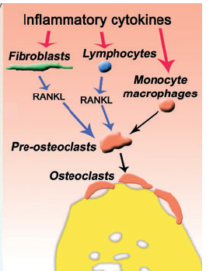

**Osteoprotegerin :( Simon et al, 1997 )**

* It is a natural inhibitor of RANKL.
* It is a soluble tumor necrosis factor receptor-like molecule
* acts as a decoy receptor.
* blocks the binding of RANKL to RANK and thus prevents osteoclastogenesis.

**RANKL ⁄ osteoprotegerin ratio in inflamed periodontal tissues**:

* found to increase either because of an increase in RANK or a decrease in osteoprotegerin,or both.
* increased at sites of periodontal inflammation.
* also correlates disease severity.

BONE CHANGES ASSOCIATED WITH FORCES :

Deformation associated with migration :

* It is achieved through removal of bone along resorbing side and concomitant deposition of bone along apposition side.

i.On resorbing side : (on pressure side)

osteoclasts excavate bundle bone pass through matrix resorbs supporting bone

* Here, the pdl anchorage loses locally

then the reversal phage begins, when the exact limit reached by resorption.

* Fibroblasts attracted to lacunae during reversal phase, secretes collagen fibrils which reconstitute fiber bundles and secrete bone matrix.
* Mineralization anchors sharpeys fibers in osteiod.
* Asynchronicity of foci allows high level of anchorage.

ii. On apposition side :( tension side )

* It is characterised by presence of continuous row of osteoblastic cells embedded in between sharpeys fibers.
* These cells contain osteocalcin and osteonectin confirming the deposition and mineralisation of bone.

**PATHOLOGIES AFFECTING BONE :**

* Systemic and Congenital diseases :
  + Osteoporosis
  + Osteogenesis imperfecta affects quality and quantity of bone.
  + Type II diabetes
  + Estrogen deficiency
* Secondary
  + Periodontitis leads to destruction of bone by spreading of inflammation.
  + Trauma from occlusion.

BONE DESTRUCTION PATTERNS :

* Most common cause ----- Extension of gingival inflammation

**PATH WAY OF SPREAD OF INFLAMMATION:**

* Interproximally :

From gingiva Bone

From gingiva PDL

From bone PDL

* Facially and lingually

From gingiva along outer periosteum

From periosteum bone

From gingiva PDL

* Radius of action is 1.5 to 2.5mm within which local factors can induce loss of bone.
* Bone loss can be localised or generalised

horizontal or vertical/angular

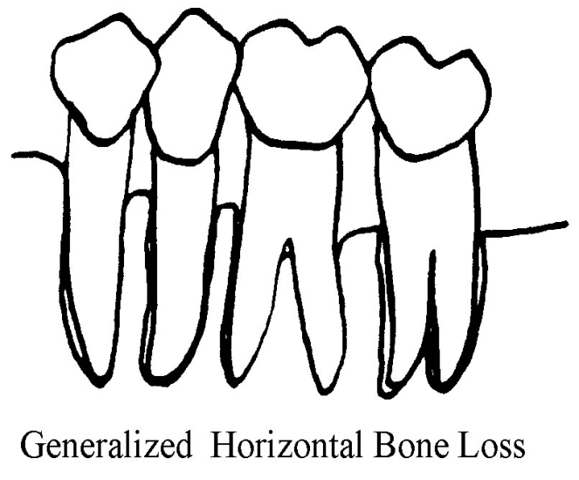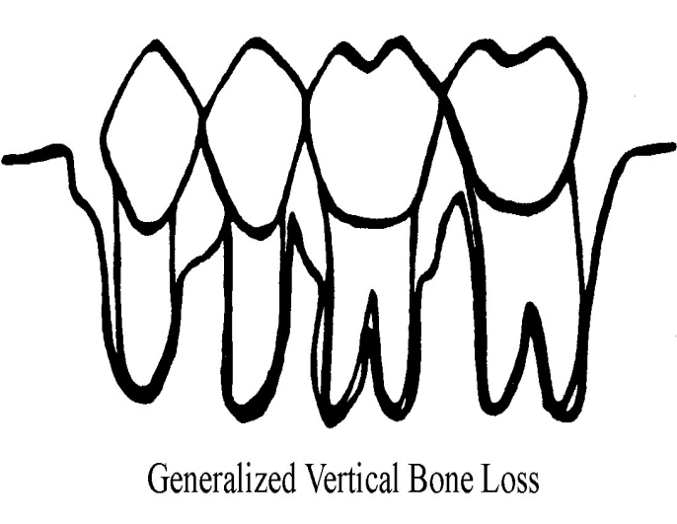

* Angular defects are classified as

Three-wall, two-wall and one-wall defects on the basis of the number of residual alveolar bone walls.

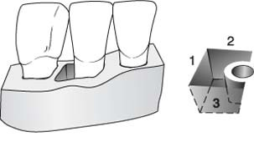

3 wall defect

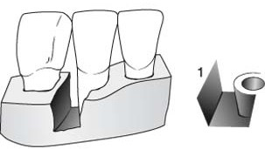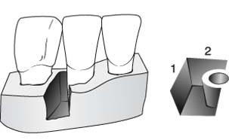

2 wall defect 1 wall defect

* Fenestration : isolated areas in which root is denuded of bone and root surface is covered only by periosteum and overlying gingiva
* Dehiscence : when the denuded areas extend through marginal bone then it is called as dehiscence

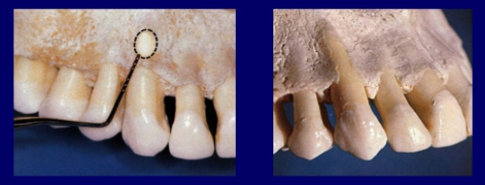

Vascular supply :

* Blood supply :
  + Vessels branching from superior alveolar

and inferior alveolar arteries.

* Lymphatic drainage :
  + All third molars : jugulodigastric lymphnodes
  + Mandibular incisors : submental lymphnodes
  + Remaining teeth : sub mandibular lymph nodes
* Therapeutic approaches to treat pathologic bone loss :

1. Conventional :

NSAIDS

Glucocorticoids

2. anti-Tumor necrosis factor alpha :

3. Interleukins

anti cytokine agents

4. Anti resorptive therapies :

i. bisphosphonates

ii. Hormone replacement therapy

iii RANK/RANKL interactions

* Commercially available drugs

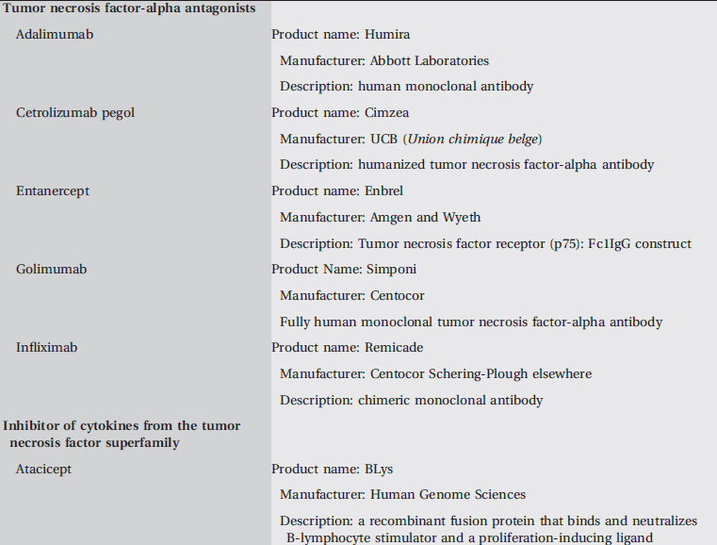

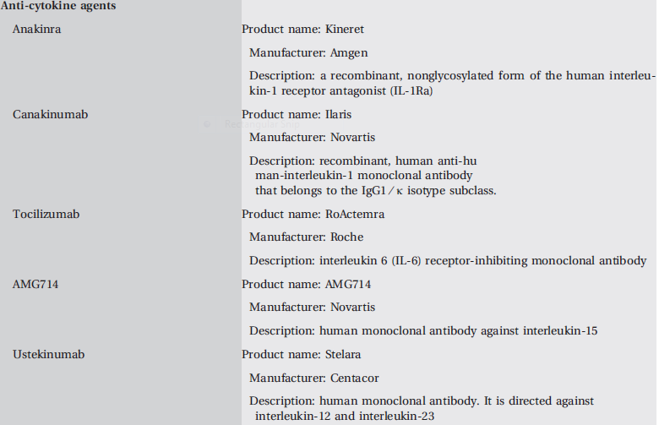

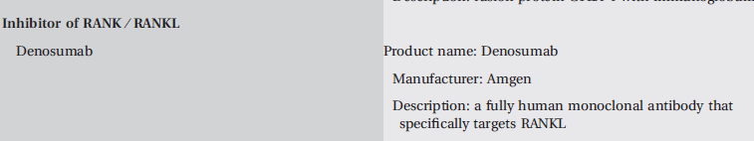

**CONCLUSION:**

* Alveolar bone, has an interdependence with the dentition, has a specialized role in the support of teeth with the basic cellular and matrix components.
* Many factors that regulate bone remodeling appear to exert their effects either directly or indirectly through the genes, which have become important targets for developing pharmacological and clinical strategies to regulate the rate of bone formation and resorption that will be important for maintenance of a healthy periodontium.

**REFERENCES:**

* Carranza’s textbook of periodontology 10th edition.
* Text book of periodontology, John lindhe, 5th edition.
* Alveolar bone and alveolar process ,Perio2000 vol.13, 1997 ,76-90.
* Molecular and cell biology of alveolar bone

Perio2000,vol.24, 2000 ,99-126.

* Mechanisms and control of pathologic bone loss

Perio2000,vol.53, 2010, 55-69.